Microsoft One Drive Instructions

- Click on the one of the links received through email about Folder Access.
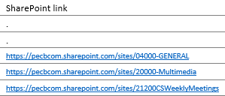

- After clicking on the link, a Microsoft Edge will open. Click on Documents as shown in a figure below.

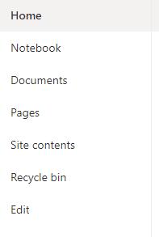

- Click on Sync as shown in a figure, at the top of the screen.
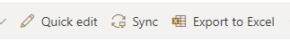

- A pop up message will appear, Click Open.

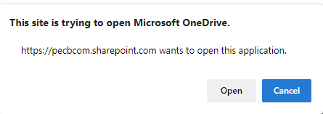

- After you Click Open, your folder will begin to Sync on PECB One Drive. You will find One Drive at File Explorer as shown in a figure below.

