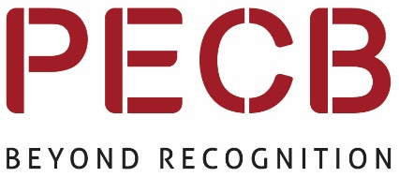

Information Security Self-Study Training Courses
Self-study is a great opportunity to enhance your knowledge and improve your performance.
Why not take the opportunity to use this easily accessible and low-cost tool?

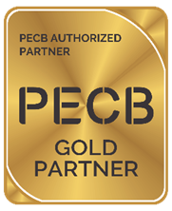
Inlexso, a Gold Partner with PECB, provides the following self-study training through the KATE app:
- ISO/IEC 27001 & ISO/IEC 27002 – Information Security
- ISO/IEC 27005 – Information Security Risk Management
- ISO/IEC 27032 – Cyber Security
- Computer Forensics

Benefits of Self-study training:
- Flexible self-paced learning
- Flexible time allocation
- Official PECB materials designed to facilitate exam preparation
- KATE app allowing remote learning
- Exam can be taken at a time and date that is convenient for the candidate
- Cost effective learning

To qualify for a special reduced rate on bookings, please contact:
ISOSolutions@inlexso.co.za , call +27 82 552 359 or www.inlexso.co.za

